
SYMBIOSIS INSTITUTE OF TECHNOLOGY, PUNE
Symbiosis International (Deemed University)
(Established under section 3 of the UGC Act, 1956)
Re-accredited by NAAC with ‘A’ grade (3.58/4) | Awarded Category – I by UGC
Founder: Prof. Dr. S. B. Mujumdar, M. Sc., Ph. D. (Awarded Padma Bhushan and Padma Shri by President of India)

Assignment No. 09

Subject: | DevOps Lab
TCODE: | TE7950
Name of Student | Yash Patel
PRN No. | 23070122235
Branch | CSE, Batch (2023-27), L3
Academic Year &  Semester | 25 – 26, Sem VII
Date of Performance | 23rd July, 2026
Title of Assignment: | Container Management & Networking
Theory: | Docker container management is the process of creating, running, monitoring, stopping, inspecting, and removing containers. Port mapping allows applications running inside a container to be accessed from the host machine by mapping a host port to a container port. Docker provides commands such as docker ps to view running containers, docker inspect to examine detailed container configuration and network settings, docker stop to gracefully stop a container, and docker rm to remove unused containers. These commands help efficiently manage the lifecycle of Docker containers and verify their network configuration and status.  Commands Used  - Created and started the Docker container in detached mode with port mapping:  docker run -d -p 8081:5000 --name flask-network-demo my-flask-app  - Listed all running Docker containers:  docker ps  - Stopped the running Docker container:  docker stop flask-network-demo  - Listed all Docker containers, including stopped containers:  docker ps -a  - Inspected the container's network configuration and settings:  docker inspect flask-network-demo  - Removed the stopped Docker container:  docker rm flask-network-demo  - Verified that the container had been removed:  docker ps -a
Implementation: | Step 1: Run a Container with Port Mapping  Started Docker Container — Started the Docker container named flask-network-demo in detached mode and mapped host port 8081 to container port 5000, allowing the application to run in the background.  Step 2: Access the Application via Your Browser  Verified Application Access — Accessed the Dockerized Flask application through http://localhost:8081 and verified that the application was successfully running inside the Docker container.  Step 3: List Running Containers  Listed Running Containers — Displayed all currently running Docker containers using the docker ps command and verified that the flask-network-demo container was running with port mapping from 8081 on the host to 5000 inside the container.  Step 4: Stop the Running Container  Stopped Docker Container — Stopped the running flask-network-demo container using the docker stop command, terminating the application gracefully.  Step 5: List Running and All Containers  Verified Container Status — Used the docker ps -a command to display all Docker containers and verified that the flask-network-demo container had stopped successfully and was in the Exited state.  Step 6: Inspect the Container's Network Settings  Inspected Container Network Settings — Used the docker inspect command to view detailed information about the flask-network-demo container, including its NetworkSettings and network configuration.  Step 7: Remove the Stopped Container  Removed Docker Container — Removed the flask-network-demo container using the docker rm command and verified its successful removal by confirming that it no longer appeared in the list of Docker containers.  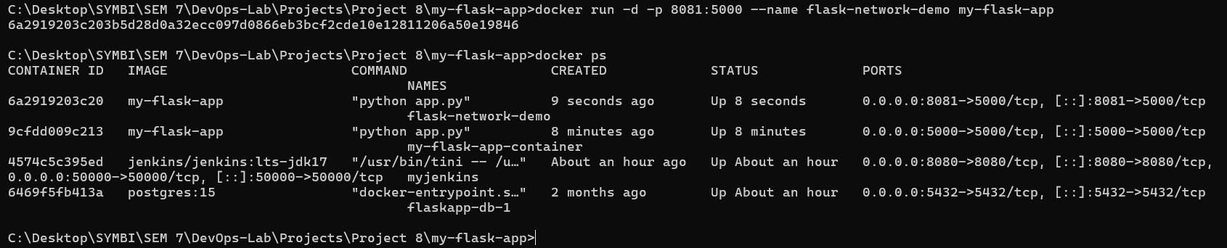  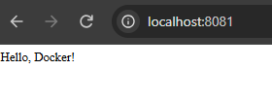  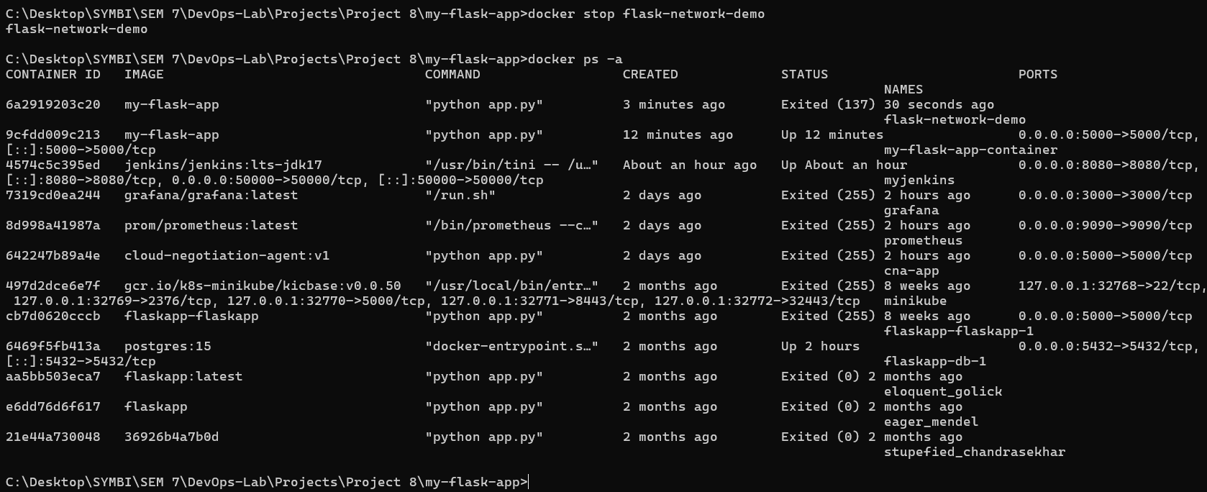  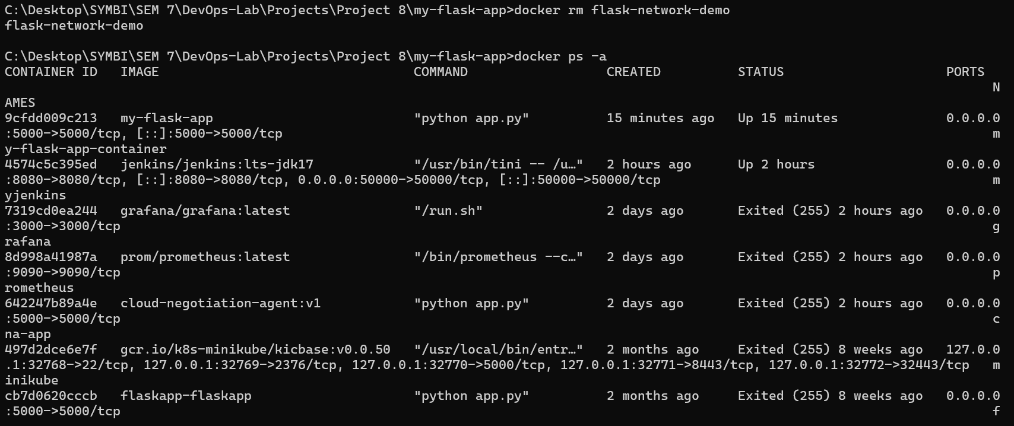  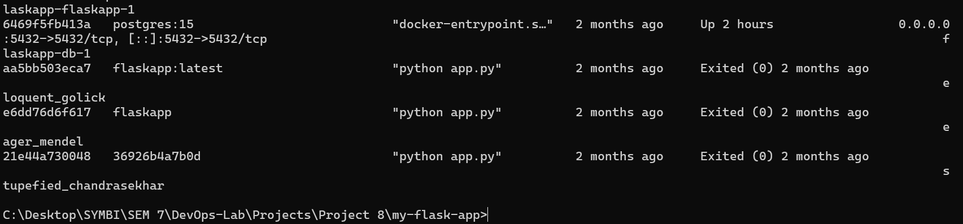

Subject Faculty Name: Prof. Arijit Dutta

